CS 255 System Design Document
Benjamin Holcomb

UML Diagrams

UML Use Case Diagram
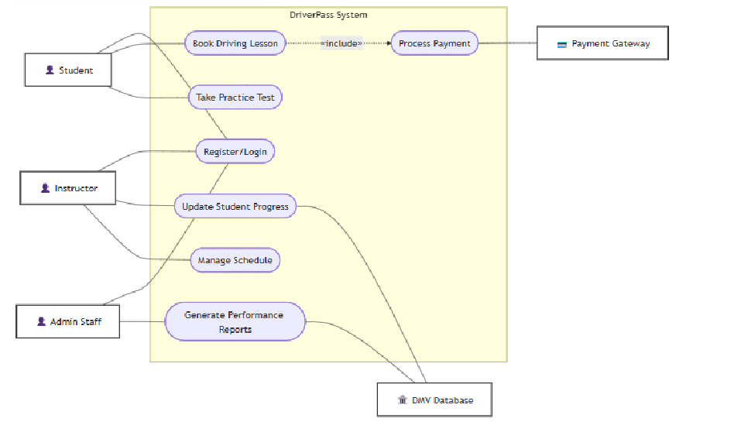

UML Activity Diagrams
For User Login:
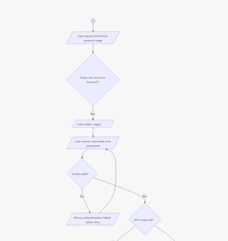
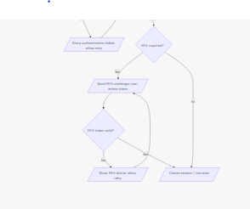

For Taking a practice test:
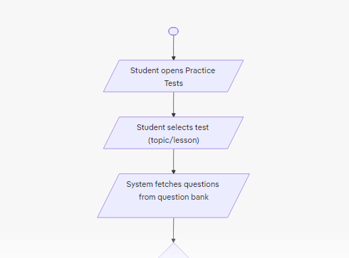
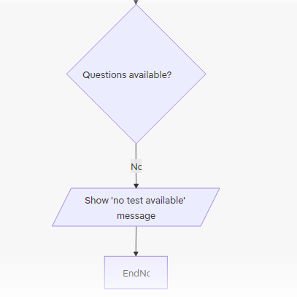

UML Sequence Diagram
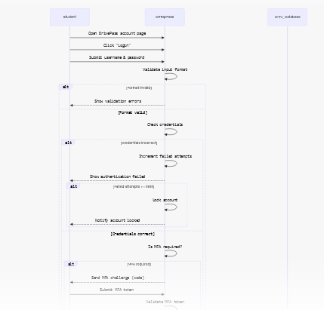
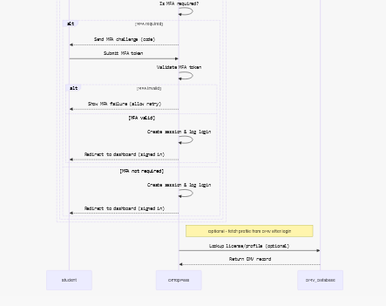

UML Class Diagram
May have gone a little overboard here

Technical Requirements
Hardware and hosting: Run the system in the cloud using virtual servers or managed containers, with separate instances for the web/API layer, background workers, and the database. Use fast SSD storage and object storage for files (test content, receipts).
Software and platform: Build a web API and a frontend web app (and optionally mobile apps). Store core data (students, instructors, lessons, schedules, payments) in a managed database and use a simple search/index service for lesson lookup. Use background processes for tasks like processing payments, scoring tests, generating reports, and submitting records to the DMV. Integrate with a payment provider and the DMV via their APIs.
Operations and tools: Use automated build-and-deploy pipelines and infrastructure provisioning tools so releases are repeatable. Keep secrets (API keys, payment tokens) in a secure vault. Monitor service health, collect logs, and set up alerts for failures. Maintain automated backups and a recovery plan.
Security and compliance: Protect all traffic and store sensitive data encrypted. Use role-based access for students, instructors, and admin staff and regularly apply security updates.
Non-functional expectations: Aim for high availability and responsive UI (fast search and schedule lookups). Background tasks (reports, DMV submissions) can run asynchronously. Design so the system can scale horizontally as user demand grows.

